المحاضرة ( 4 )
Maximum Likelihood Estimation
Definition : Let X1; :::;Xn have a joint pmf or pdf f (x1; :::; xn; f1; :::; fm) (1) where the parameters _1; :::; _m have unknown values. When x1; :::; xn are observed samples values and (1)is regarded as a function of f1; :::; fm, it is called the likelihood function. L(f1; :::; fm) = f (x1; :::; xn; f1; :::; fm)
The maximum likelihood estimates (mle's) f1; ::: fm are those values of the i 's that maximize the likelihood function, so that
L(f1; :::; fm) = L(f1; :::; fm)
Example: Let X1; :::Xn be a random sample from the normal distribution.
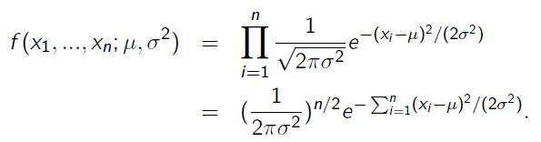
The natural logarithm of the likelihood function is
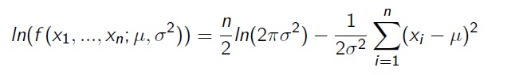

To find the maximizing values of µ and , we must take the partial derivatives of ln(f ) with respect to µ and equate them to zero, and solve the resulting two equations. Omitting the details, the resulting mle’s are
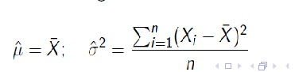
The Method of Moments
The basic idea of this method is to equate certain sample characteristics, such as the mean, to the corresponding population expected values. Then solving these equations for unknown parameter values yields the estimators.

Definition: Let X1; :::;Xn be a random sample from a pmf or pdf f (x). For k = 1; 2; 3; :::; the kth population moment, or kth moment of the distribution f (x), is E(Xk ). The kth sample moment is
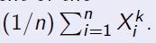
Thus the _rst population moment is E(X) = µ, and the first sample
moment is
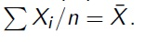

The population moments will be functions of any unknown parameters 01; :::; 0m.
Example :
